Derek has been often called the “Apartment Guru” due to his decades of speaking, writing, consulting, brokerage transactions, relationships, amortized knowledge, and industry wisdom. His keen insight and strategies have allowed him to broker some of the nation’s largest and most complex real estate transactions.

Derek has authored 18 books to date and is the visionary behind the Apartment University learning portal. His mission is to impact one if the world’s greatest challenges.... the lack of rental housing.

As one of the most-connected individuals in the apartment industry, Derek continues to live by his personal motto, “always stay in traffic!” Now in his 5th decade of business, his desire is to become an “Apartment Collaborator” by bringing together like-minded talented people to work with and solve the business challenges and opportunities in rental housing.

Current Positions:

CEO, SVN Rock Advisors Inc., Brokerage (2007 – Present)
- SVN Rock Advisors Inc., Brokerage is a Commercial Real Estate firm, specializing in rental apartments, new apartment construction, and student housing, and complex family transactions.

CEO, Derek A. Lobo & Associates Inc. (DALA) Group of Companies (1988-Present)
- DALA Group of Companies is a consulting agency focused on the revenue maximization of purpose-built apartments. DALA Group advises apartment owners on how to maximize their NOI and is typically paid on performance. We conduct on-site marketing programs, feasibility studies on new apartment construction, and research market conditions to assist clients in increasing cash flow.

U.S. Experience
- Derek has worked in numerous U.S. states including Alabama, Arizona, California, Florida, Georgia, Michigan, New York, Oklahoma, Pennsylvania, and Texas as an apartment consultant.

- Derek has worked for many U.S. apartment owners and developers including:
  - Equity Residential, Flagship Properties, Home Properties, Lane Company, Morgan Stanley, Village Green Companies

Speaking Experience

- Well-known for his thought leadership, Derek is a sought-after speaker and presenter on topics affecting the Apartment Industry, Student Housing, Rent Control, and the factors driving its future in both Canada and the U.S.
- Derek has spoken to several American organizations including:
  - National Apartment Association, National Multi-Housing Council, Multi-Housing World

Publishing Experience
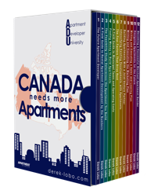
- Derek has published multiple books sharing his expertise on topics affecting the Apartment Industry:
  - How to Rent Apartments Fast, How to Take a Building to Rent Review, The Future Apartment Developer
- Derek has illustrated the power of (re)-positioning to Canadian apartment developers, investors, and owners by hosting intimate tours of key properties in prime U.S. markets. These events provide valuable exposure to successful high-end rental apartment concepts.

Memberships:

- Real Estate Council of Ontario (RECO)
- Canadian Real Estate Association (CREA)
- Toronto Real Estate Board (TREB)
- Federation of Rental Housing Providers of Ontario
- Hamilton and District Apartment Association
- Greater Toronto Apartment Association

Past Positions:

- President, Hamilton & District Apartment Association (Jan 1991-Dec 1993)
- Board Member, Federation of Rental Housing Providers of Ontario

Education:

Ryerson University, Toronto, Ontario (1977-1980)

Public Company Positions:

- Board Member, Starlight Multi-Family Fund USA (2013-2015)

Attached:

- Derek Lobo’s Business History

Clients:
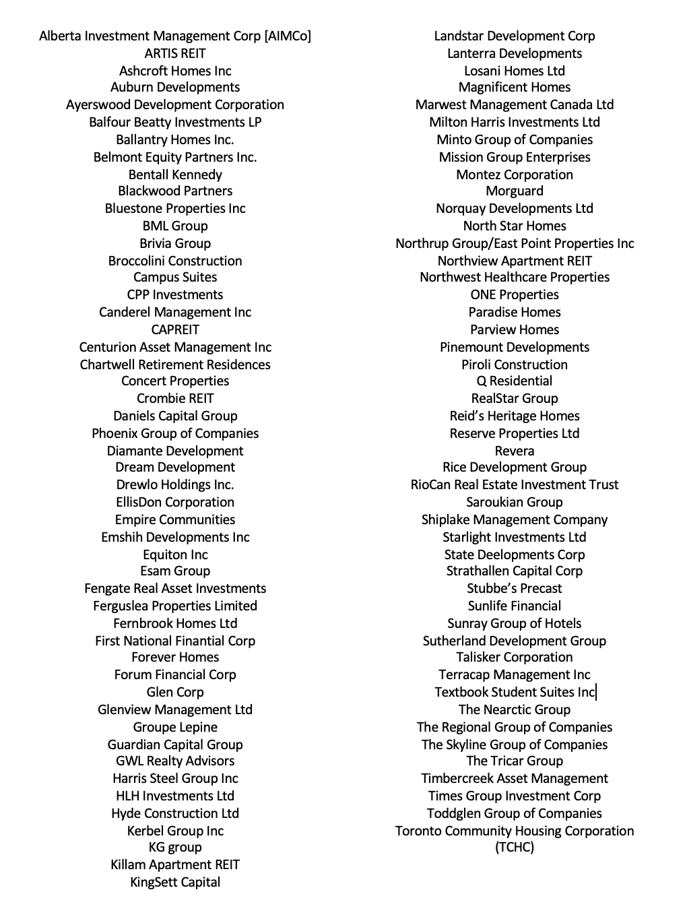

Business History:

Summer 2021 | 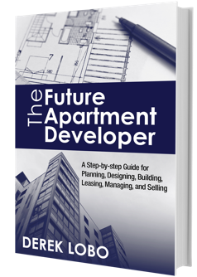  Published Hardcover Book: The Future Apartment Developer along with Online Learning Portal: derek-lobo.com
2021 | 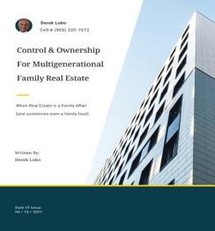  Released white paper titled Control and Ownership for Multigenerational Family Real Estate svnrock.ca/family
2020 | Launched Educational Webinar Series:  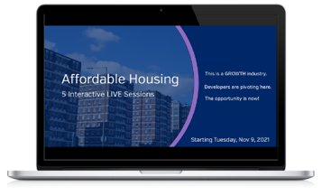  - Apartment Developer University  - Apartment Leasing University  - Developing Affordable Housing
2019 | Leased up and facilitated sale of The Taunton Luxury Apartments,  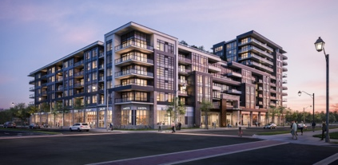  286 units at a sale price of $164 million.
2019 | 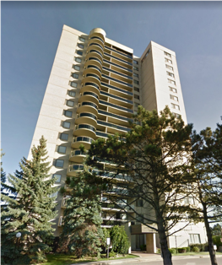  Sold Rossland Park (family transaction), 911 units at a sale price of $220 million.
2018 | Sold Collegeview Commons (student housing), 1020 beds, at a sale price of $74.6 million.
2017 | 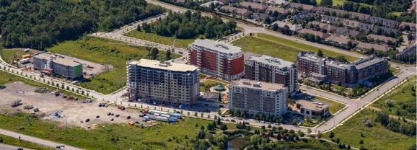  Sold the largest new apartment complex in Canadian history, over 700 units at a sale price of over $250 million. Play Video
2015 | Acting VP at Canadian Apartments Properties Real Estate Investment Trust (CAPREIT)
2012 -  2019 | New Apartment Construction Symposium Recognizing the lack of information on New Apartment Construction in the Canadian marketplace ROCK began hosting 2-day conferences on New Apartment Construction. The symposium has established itself as an industry event in the Canadian apartment development industry.  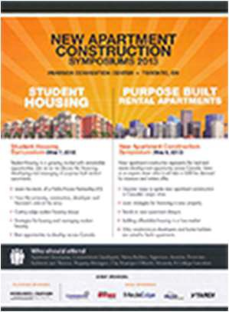  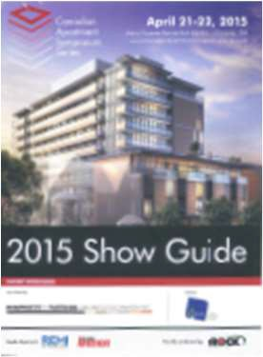  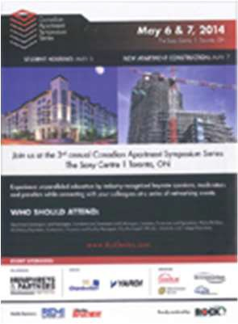  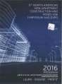

2011 | 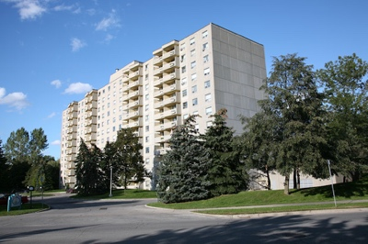  Sold the largest apartment transaction in Canada. The transaction included 13 buildings (2,300) apartments, a shopping center and a medical office building in London, Ontario. The property was bought by a major Canadian pension fund, the largest private financial equity group in Canada, and one of the larger owner/operator/developers in the country. Play Video
2011 -  Present | New Apartment Construction Consulting  Using the same process for student housing, Derek analyzed his U.S. counterparts and developed a New Apartment Construction consulting business. Today Derek A. Lobo and Associates (DALA) is the largest consulting firm in this sector in Canada. Services include new apartment construction feasibility studies for developers and lenders, project financing, strategic marketing planning, asset management, and disposition. Play Video
2007 | Sold Canada’s first Student Housing Portfolio to division of CDP Capital (the largest pension fund in Canada).
2007 | Established Rock Advisors Inc., Brokerage. Rock was the first apartment brokerage firm in Canada to truly combine advisory services and a boutique apartment brokerage.
2003 -  Present | Student Housing Consulting  In early 2000’s Derek recognized there was no functioning student housing business market in Canada and was the first Canadian (after studying the U.S. market) to enter the student housing consulting market. Derek ran his first student housing symposium in 2012 and has been responsible for the sale of over $300 million in student housing transactions.
1996 | 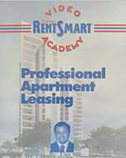  Self-produced RentSmart Video Academy included 12 videos and 12 cassette tapes along with books. The training programs generated $250,000 in sales.
1993 | 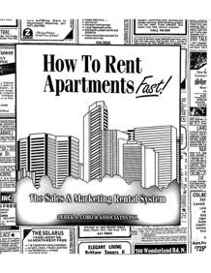  Self-published How to Rent Apartments Fast! a 500- page book which included two videos.
1980 -  Present | Performance Based Consulting and Asset Management In the late 80’s and early 90’s Derek spent considerable time in the U.S. acquiring practical knowledge on the sales and marketing of rental apartments and brought expertise back to the Canadian marketplace. Consulting services included NOI enhancement, sales training, marketing plans, contract leasing, rental pricing strategy, mystery shopping, and filling other gaps in the rental housing industry.
1987-1990 | Rent Review Consultant – Represented beneficial apartment owners through the quasi-judicial rent review and application process. Hearings were conducted under the Statutory Procedures Act. Derek became an expert in Ontario rent regulation.
1987 | 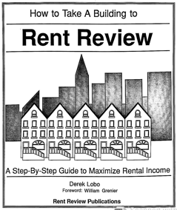  Self-Published How to Take a Building to Rent Review
1986 - 1990 | Syndicated Limited Partnerships - apartment owner, investor, and manager.

Future Timeline:

